2.PROBLEM DEFINITION &DESIGN THINKING

2.1 Empathy Map

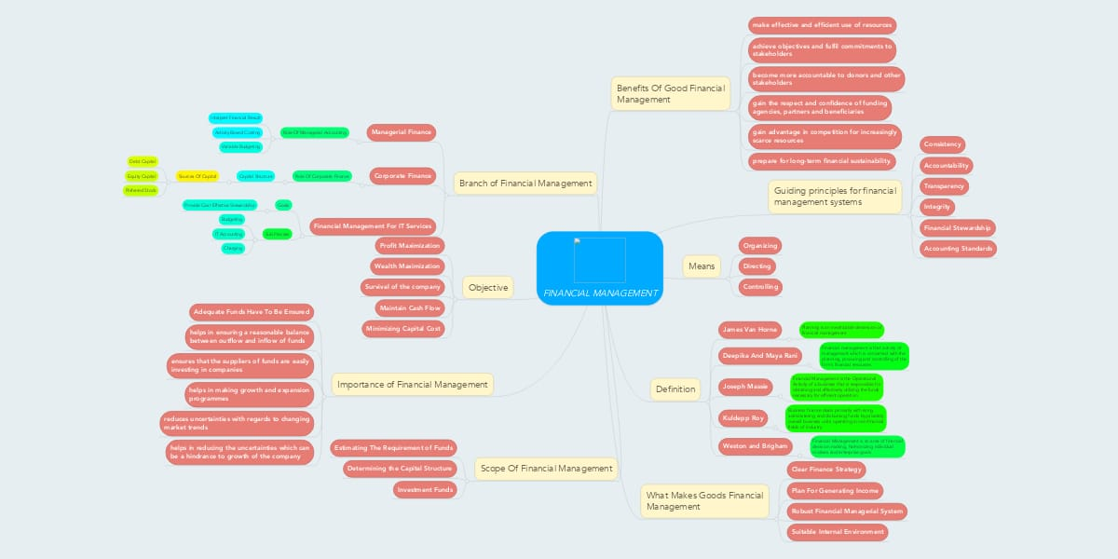

2.2 Ideation and Brainstorming Map

